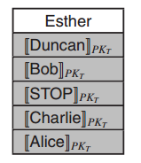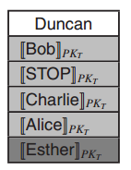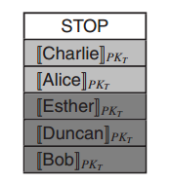

**Reordered Ballot Form**

Dummy Position Candidate Unchanged

Only the registrars can read the candidate list on

the left side

Only the tellers can read the onions on the right side

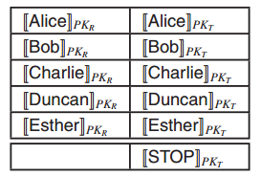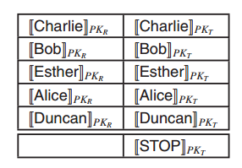

**Initial Ballot Form**

Left Side: Registers

Right Side: Tellers

Encryption of candidate indexes